**Exercise 4: Employee Management System – Implementing CRUD Operations**

Business Scenario:

Implement CRUD operations for managing employees and departments.

**1. Basic CRUD Operations:**

* JpaRepository provides a set of built-in methods for basic CRUD operations (Create, Read, Update, Delete). These methods can be used directly in the repository interfaces for Employee and Department. I used the JPARepository methods to create, read, update and delete employees and department.

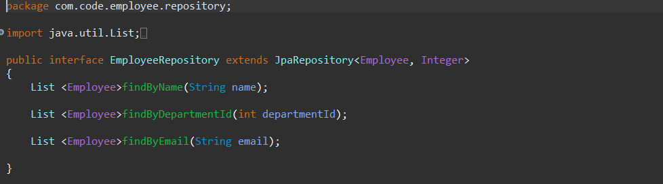

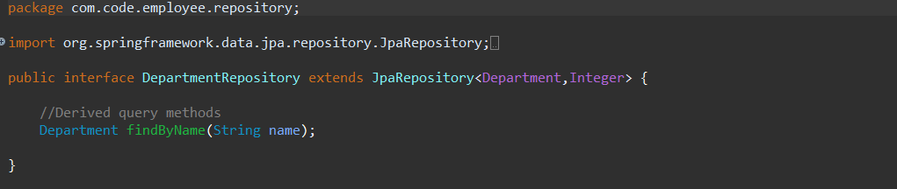

* To expose these CRUD operations via RESTful endpoints, I'll need to create controller classes for Employee and Department. I created the EmployeeController and DepartmentController for implementing RESTful endpoints for these operations.

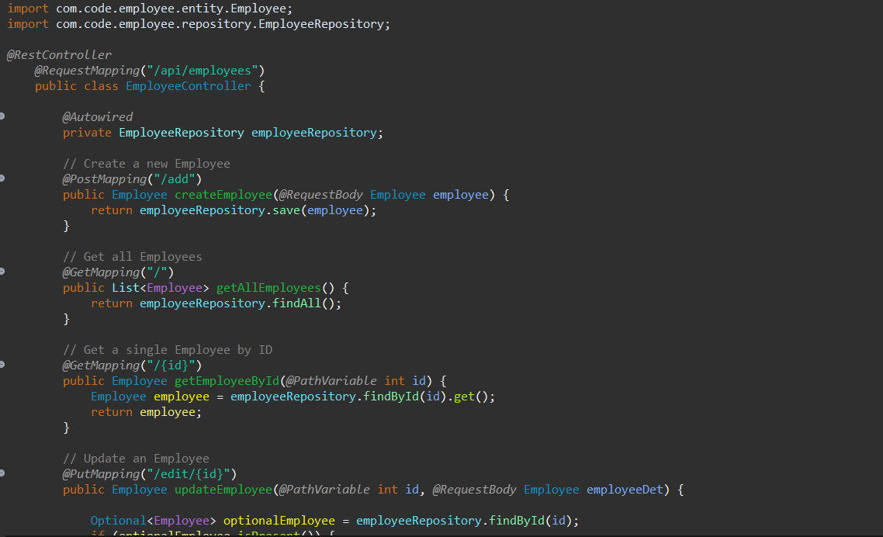

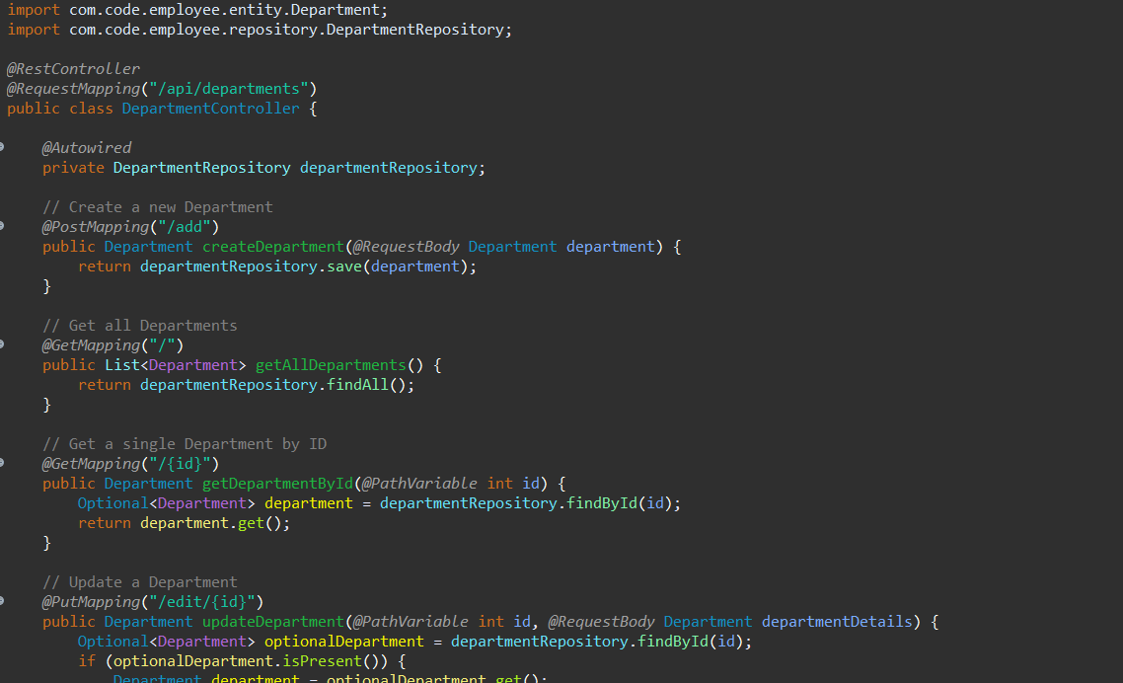

**Output:**

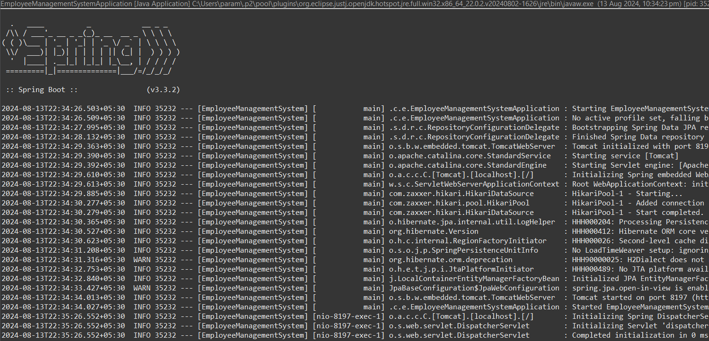

* **GET**

Initially, the repository is empty so it showing nothing.

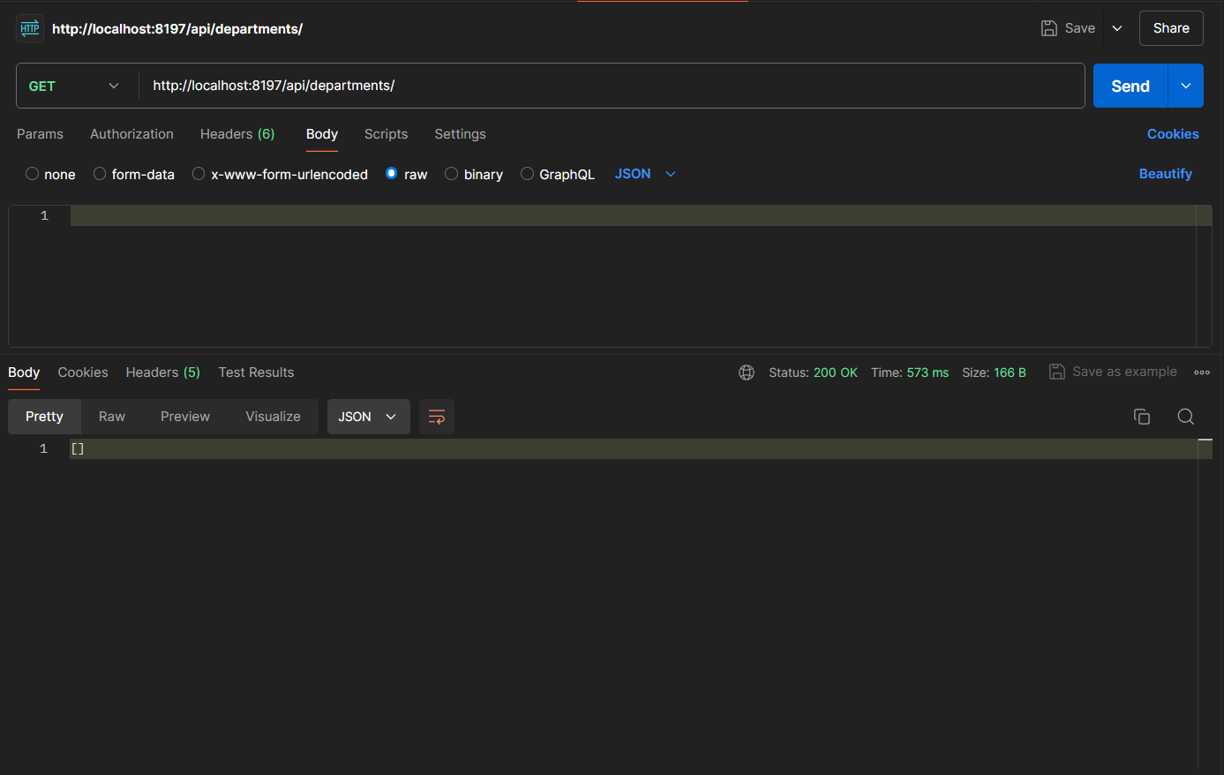

* **POST**

Adding records.

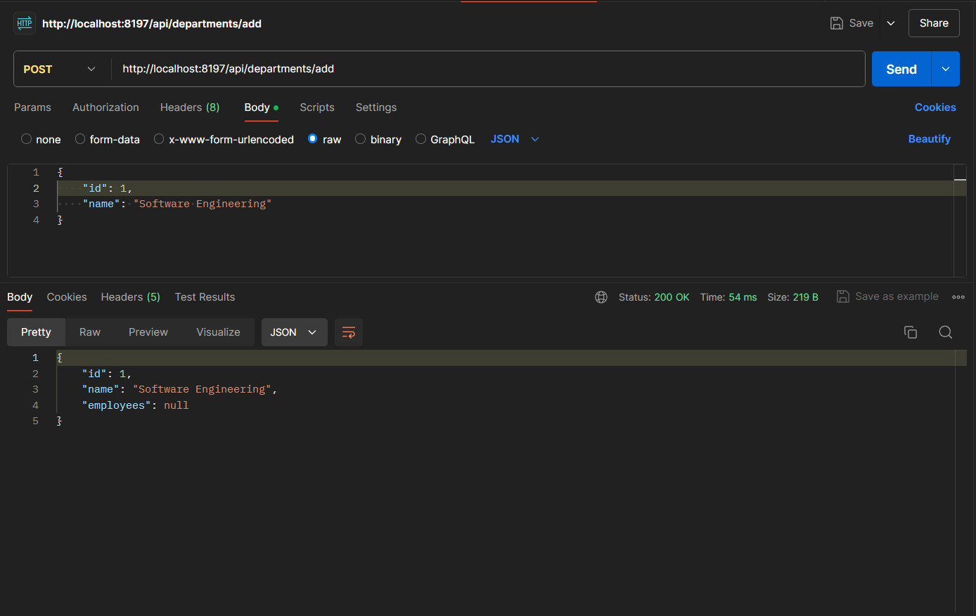

* **GET**

Displaying records.

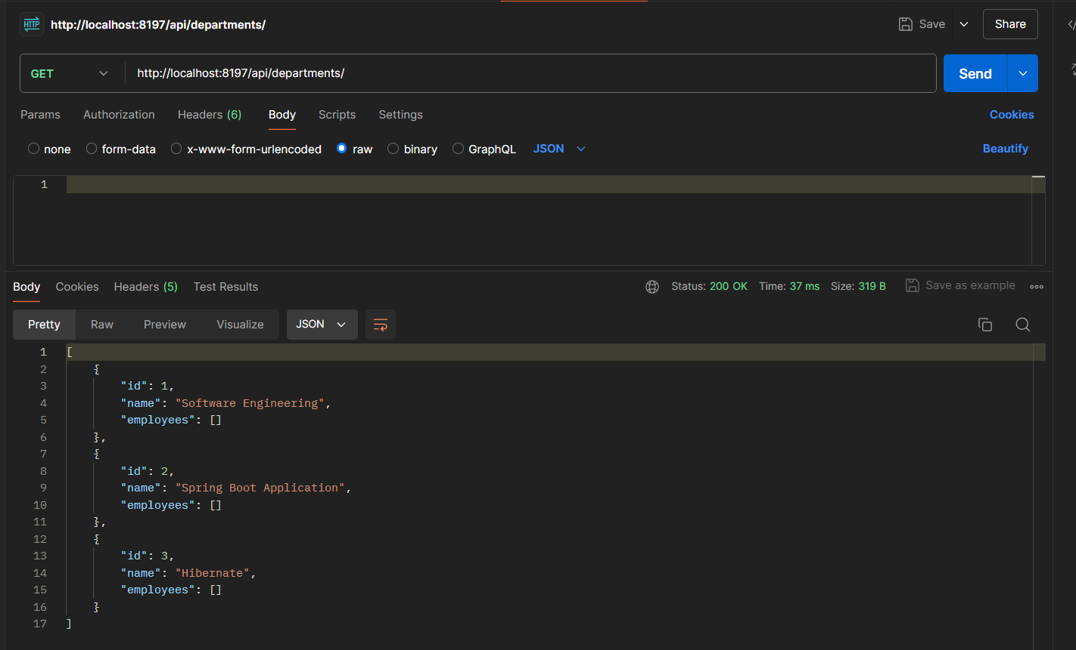

* **GET 2nd Department**

Fetching the details of record with id 2

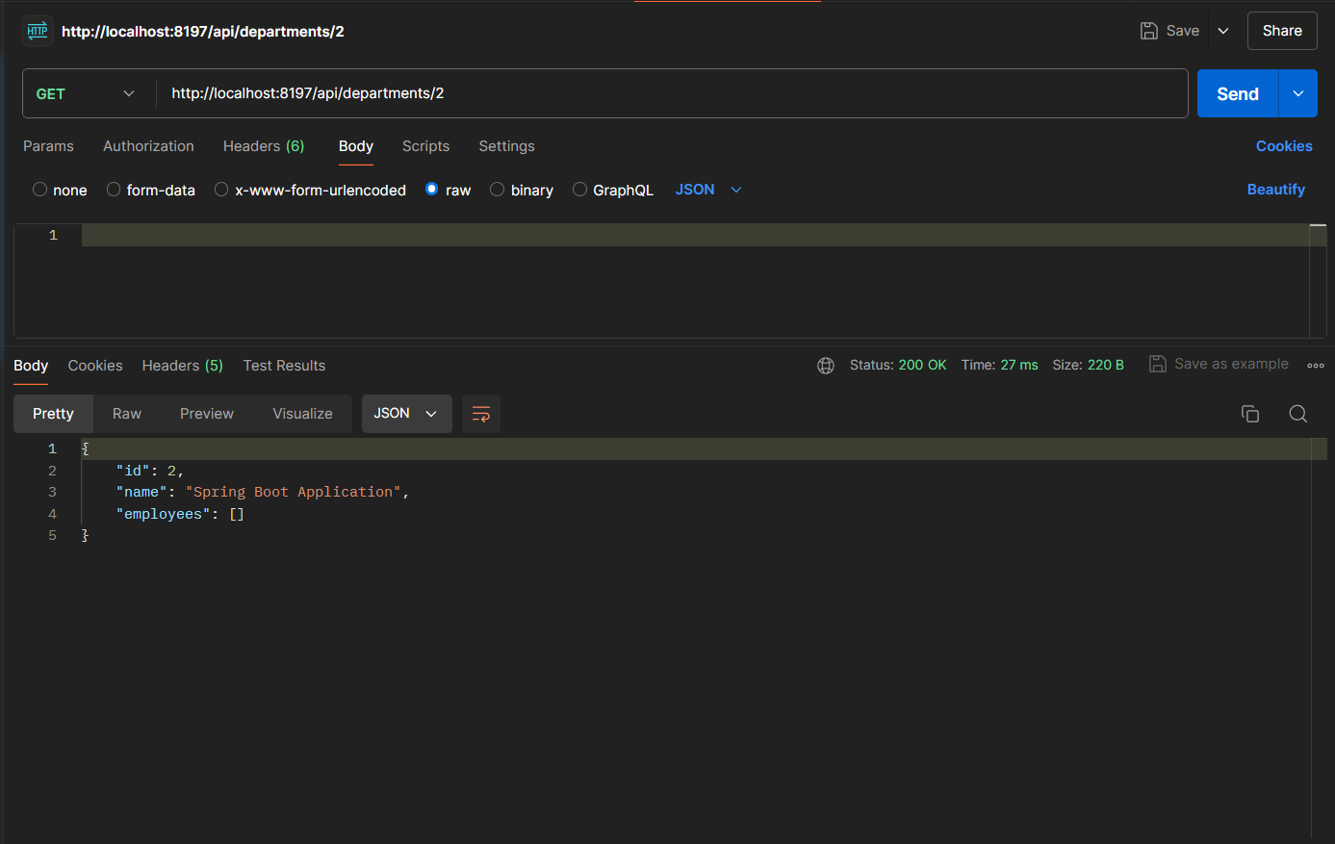

* **DELETE 1st department**

Deleting the record of department with id 1

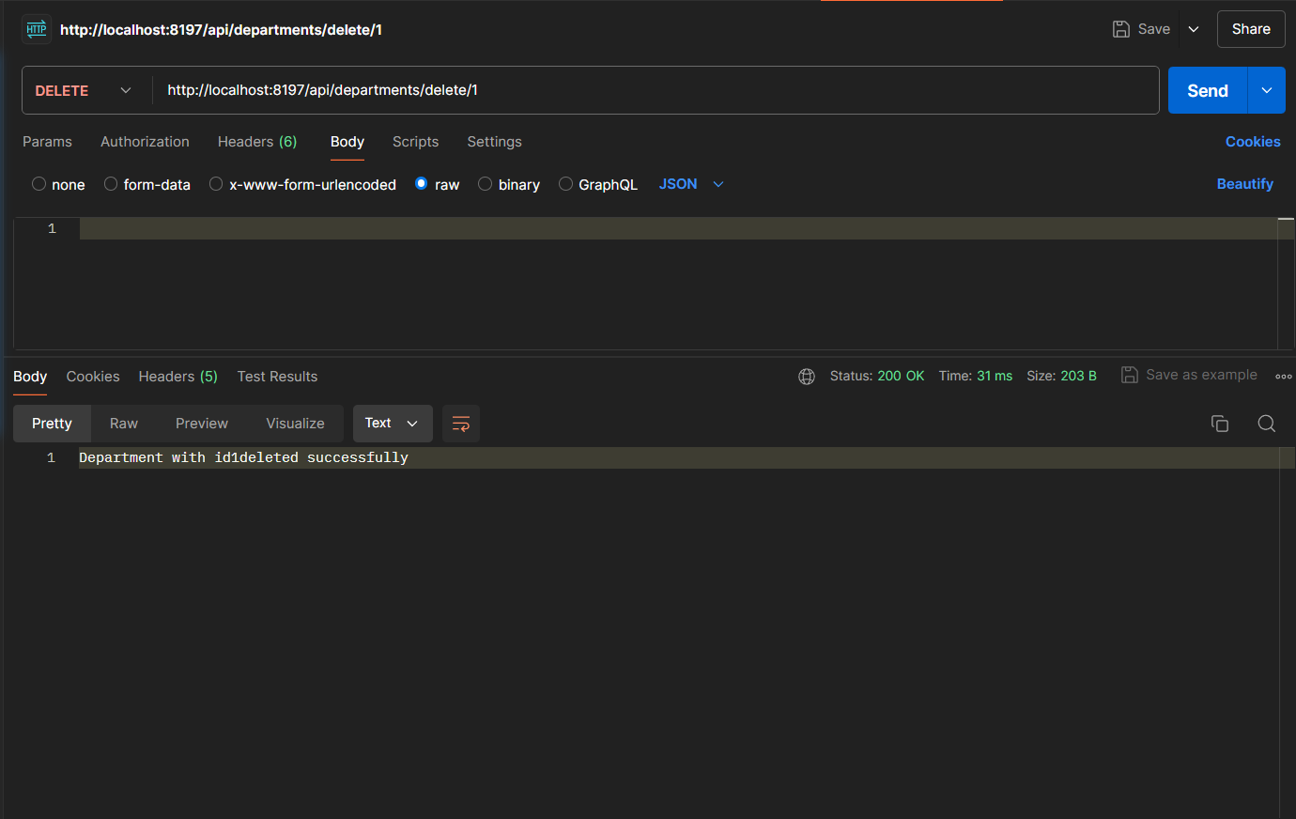

* **GET**

Displaying results

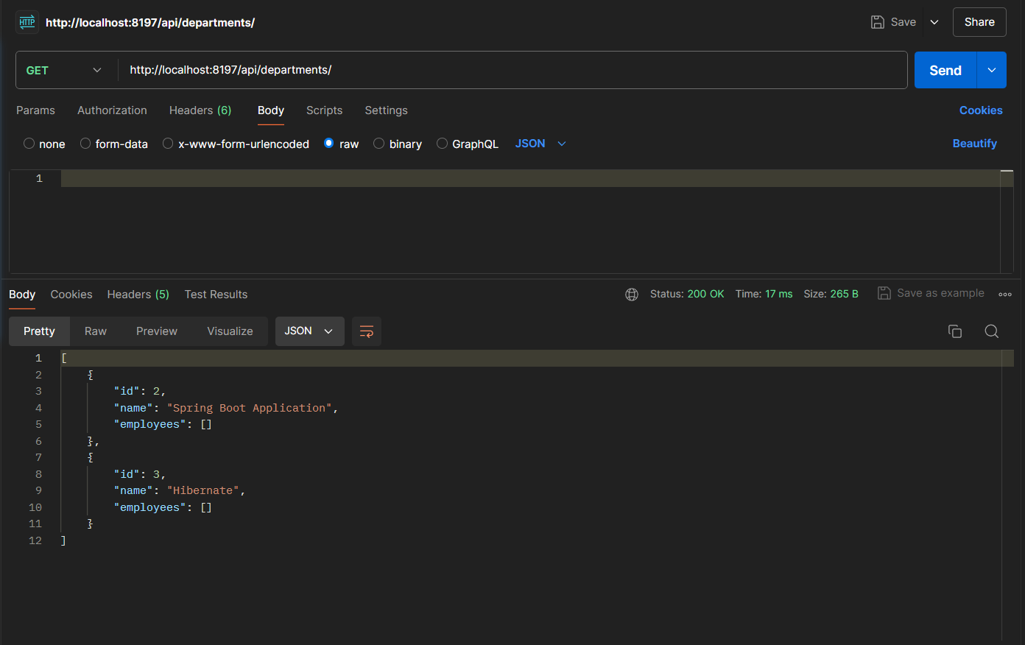

* **DELETE a department id which is not present**

Deleting department id 7 which is not present in the repository

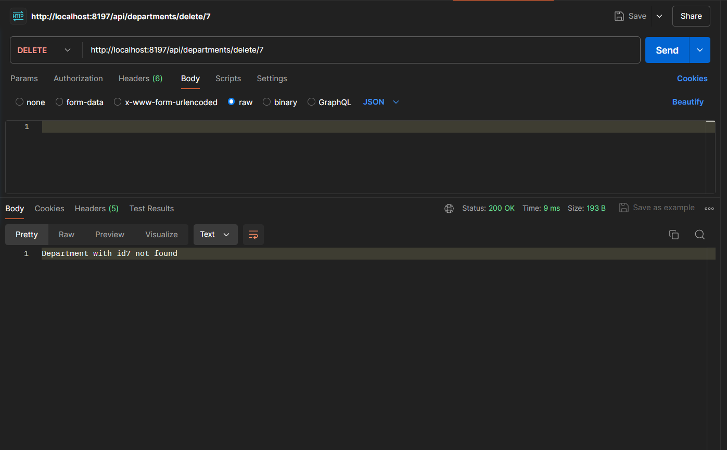

**Flowchart:**

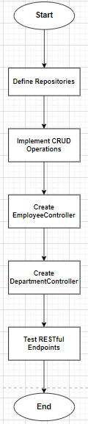

**1**: "Start"

* This is the starting point of the process.

**2**: "Define Repositories"

* This step involves creating the EmployeeRepository and DepartmentRepository interfaces extending JpaRepository.

**3**: "Implement CRUD Operations"

* This step involves using JpaRepository methods to perform create, read, update, and delete operations.

**4**: "Create EmployeeController"

* This step involves creating the EmployeeController class to expose RESTful endpoints for employee operations.

**5**: "Create DepartmentController"

* This step involves creating the DepartmentController class to expose RESTful endpoints for department operations.

**6**: "Test RESTful Endpoints"

* This step involves testing the RESTful endpoints using tools like Postman or cURL.

**7**: "End"

* This is the end of the process.

**Class Diagram:**

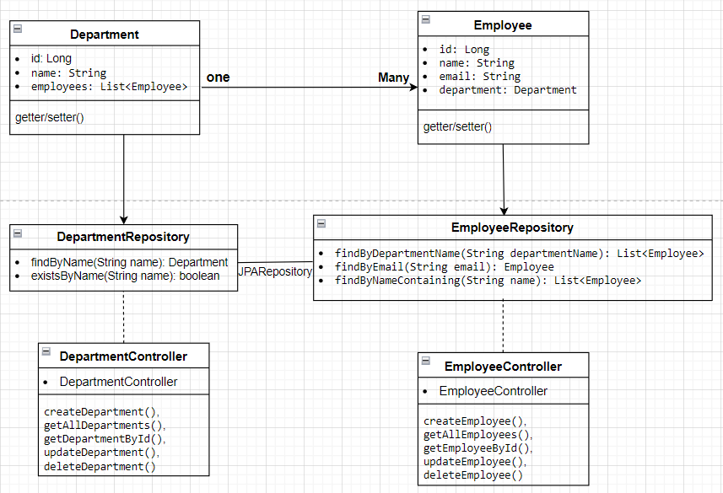

**• Department Class:**

* **Attributes: Represents the id, name, and a list of Employee objects.**
* **Relationship: Has a one-to-many relationship with Employee.**

**• Employee Class:**

* **Attributes: Represents the id, name, email, and a reference to the Department object.**
* **Relationship: Each Employee belongs to a single Department.**

**• EmployeeRepository Interface:**

* **Methods:**
  + **findByDepartmentName(String departmentName): List<Employee>**
  + **findByEmail(String email): Employee**
  + **findByNameContaining(String name): List<Employee>**

**• DepartmentRepository Interface:**

* **Methods:**
  + **findByName(String name): Department**
  + **existsByName(String name): Boolean**

**• EmployeeController Class:**

* **Methods:**
* **createEmployee()**
* **getAllEmployees()**
* **getEmployeeById()**
* **updateEmployee()**
* **deleteEmployee().**

**• DepartmentController Class:**

* **Methods**
* **createDepartment()**
* **getAllDepartments()**
* **getDepartmentById()**
* **updateDepartment()**
* **deleteDepartment()**

**Analysis:**

1. **Use JpaRepository Methods for CRUD Operations**

Basic CRUD Operations Provided by JpaRepository:

* **Create**: save(Entity entity)
* **Read**: findById(Long id), findAll()
* **Update**: save(Entity entity) (for updating existing entities)
* **Delete**: deleteById(Long id), delete(Entity entity)

**2. Implement RESTful Endpoints Using EmployeeController and DepartmentController**

To expose these CRUD operations via RESTful endpoints, you'll need to create controller classes for Employee and Department.

**Relationship:**

* Employee ↔ Department (Many-to-One)
* EmployeeRepository ↔ JpaRepository
* DepartmentRepository ↔ JpaRepository
* EmployeeController ↔ EmployeeRepository
* DepartmentController ↔ DepartmentRepository